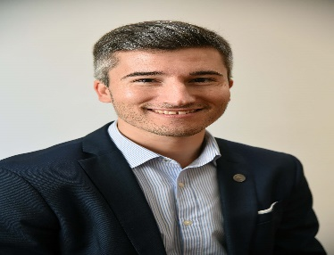
AGUSTIN TEJEDA RODRIGUEZ is currently Chief Economist at the Buenos Aires Grain Exchange. As Chief Economist, he is in charge of the departments of Economics, Agricultural Estimates, Technological Prospective and Training. He is also external consultant on agricultural and trade policies at different international organizations and institutions, such as ECLAC and ICTSD. Mr. Tejeda is professor at University of Belgrano, and teaches in postgraduate and graduate courses in different national universities. He has published several articles and papers in journals and magazines. Additionally, he was Chief Economist at INAI Foundation and advisor to the House Committee on Agriculture of Argentina.
Mr. Tejeda has a bachelor degree in Economics from the University of Buenos Aires and postgraduate studies in International Relations at the University of La Plata and Agribusiness at the University of San Andrés. In 2014, he attended to the International Visitor Leadership Program of the United States Department of State, where he studied US economic policies affecting trade and agriculture.

