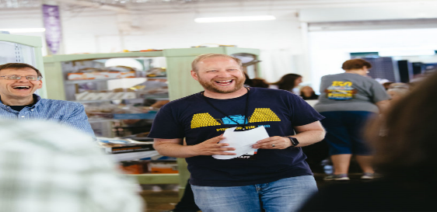
Dr. Ben Chapman is a professor and director of the Safe Plates food safety extension and research program at North Carolina State University. As a teenager, a Saturday afternoon viewing of the classic cable movie, Outbreak, sparked his interest in pathogens and public health. With the goal of reducing foodborne illness, his group researches food handling and food safety systems; designs and implements food safety strategies; and, evaluates messages and media from farm-to-fork. Through reality-based research, the Safe Plates program investigates behaviors and creates interventions aimed at amateur and professional food handlers, managers, and organizational decision-makers; the gate keepers of safe food. Ben co-hosts two podcasts, Food Safety Talk and Risky or Not and publishes the popular food safety blog, barfblog.com as well as participates in social media. Find him at @benjaminchapman on Twitter.

