QUICK REFERENCE SHEET FOR SUPPLY ORDERS
(Revised as of June 2016)

The system is set up with your individual account information but it may not display your current location/address. DON’T WORRY, you can change it later. Continue processing your Sales Order. After you have added the last item to the cart, the system will allow you to change the 37 #. When saved, the correct address will be displayed.

BASIC ORDERING PROCESS:

- Login: Salesforce with your e-auth

- Click: Create/Review Sales Order

- Click: New Sales Order. A new Sales Order Number (SO-XXXXXX) will be created (Top Left).

- Scroll down to the bottom of the screen and click: Add New Item.

- In the Filter box, enter the item name/number/description of the item you wish to order. Click: Apply Filter to search. Click on the item Name.

- That product number will appear on the Item # field (top right). Enter the quantity (delete the zeros-0.0000, enter quantity, i.e. 1 or 3). Click SAVE.

Note: You’ll get a popup box that will let you know you must submit order when finished, press OK.

- Click: Go to Sales Order. Scroll to bottom, you will see the item added. To add more items to order, repeat steps 4-7.

- When finished you must click: Submit Order. You will get a popup box to confirm the delivery address. If correct, click OK. If not, follow the steps on the next two pages (Changing Customer ID Process).

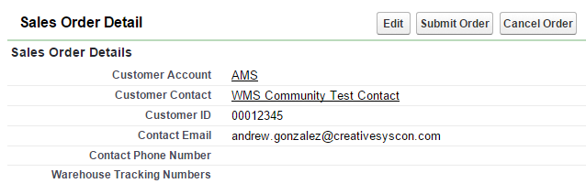
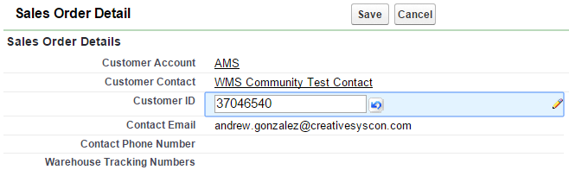
CHANGING CUSTOMER ID PROCESS:

You will see the default address at the bottom right of your screen. If the address is not correct for your order, you can edit/change the address by entering the Customer ID for that location/establishment. To do this, either click Edit (top image) or double-click the Customer ID field (bottom image) and enter the alternate Customer ID. Click SAVE.

After changing the Customer ID on the order, the associated address will be displayed as the Delivery Address (bottom right of screen).

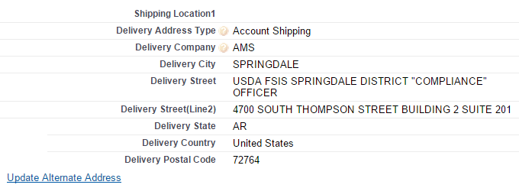

Submit order by clicking Submit Order. You will get a popup box to confirm the delivery address. If correct, click OK.

