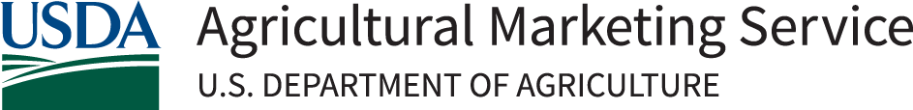
Indigenous Animals Harvesting and Meat Processing Grant Program (IAG)

Application Checklist
The application for IAG grant funds must include the following:
Forms (All forms are available via the opportunity at Grants.gov.)
☐ Form SF 424, Application for Federal Assistance
☐ Form SF 424-A, Budget Information – Non-Construction Programs
☐ Form SF 424-C, Budget Information – Construction Programs
☐ Form SF 424-D, Assurances-Construction Programs
☐ Form SF-LLL, Disclosure of Lobbying Activities

Application Template
☐ Submit all information noted in the Project Narrative Application.

Supporting Materials
☐ Environmental Checklist, or information covered in the checklist. The checklist is available at https://www.usda.gov/sites/default/files/documents/iag-environmental-checklist.pdf
☐ Approved Negotiated Indirect Cost Rate Agreement (NICRA) with the federal government (if applicable).
☐ Founding Documents/Articles of Incorporation. If the applicant is a wholly owned arm or instrumentality of a tribal government, including tribal corporations, the applicant must provide their articles of incorporation, tribal charter, or other founding/establishing document(s).
☐ Design and construction documents. For projects involving construction, include any design and construction documents. If selected for funding, the Agency will follow the construction planning and performing development regulation at 7 CFR. 4280.125.
☐ Letters of Support from relevant stakeholders.

Actions
☐ Ensure that you have an active Systems for Award Management (SAM) registration at the time of application.
☐ Review the environmental checklist to ensure you are providing all relevant environmental documentation so that a NEPA and NHHPA Section 106 environmental review can be completed. Please contact the Agency to assist in determining what documentation is required to be provided.

